PROJECT REPORT

PLUGGING INTO THE FUTURE: AN EXPLORATION OF ELECTRICITY CONSUMPTION PATTERNS

**TDMNS COLLEGE**

**T.KALLIKULAM**

DEPARTMENT: PHYSICS

TEAM- 1

J. DELPHIA MILKY

C.BALA BHUGANISHA

J.AROCKIA VINITHA

M. ARCHANA

Plugging Into The Future: An Exploration Of Electricity Consumption Patterns

Introduction:

Project Description:

India is the world's third-largest producer and third-largest consumer of electricity. The national electric grid in India has an installed capacity of 370.106 GW as of 31 March 2020. Renewable power plants, which also include large hydroelectric plants, constitute 35.86% of India's total installed capacity. During the fiscal year (FY) 2019–20, the total electricity generation in the country was 1,598 TWh, of which 1,383.5 TWh generated by utilities. The gross electricity consumption per capita in FY2019 was 1,208 kWh.

In 2015-16, electric energy consumption in agriculture was recorded as being the highest (17.89%) worldwide. The per capita electricity consumption is low compared to most other countries despite India having a low electricity tariff.

Uses of this project:

Annual electricity consumption per capita serves as an important measure of a country's electric power development. Generally speaking, electricity consumption grows faster when the industrialization process develops quickly and goes down rapidly when industrialization is completed or near completion.

Problem Definition & Design Thinking:

Empathy Map:

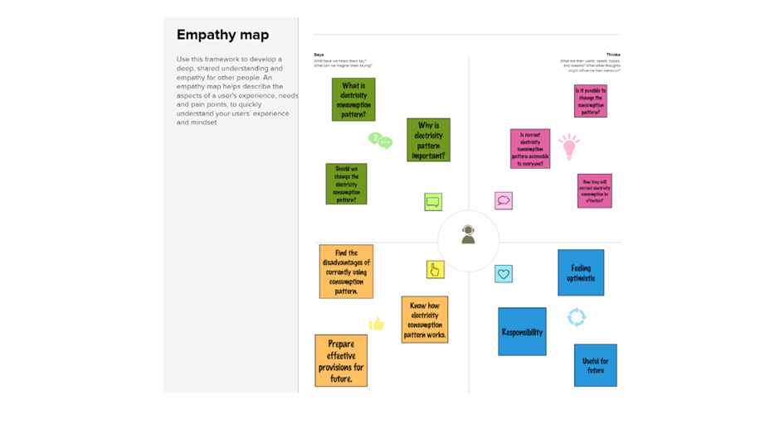

Ideation & Brainstorming Map:

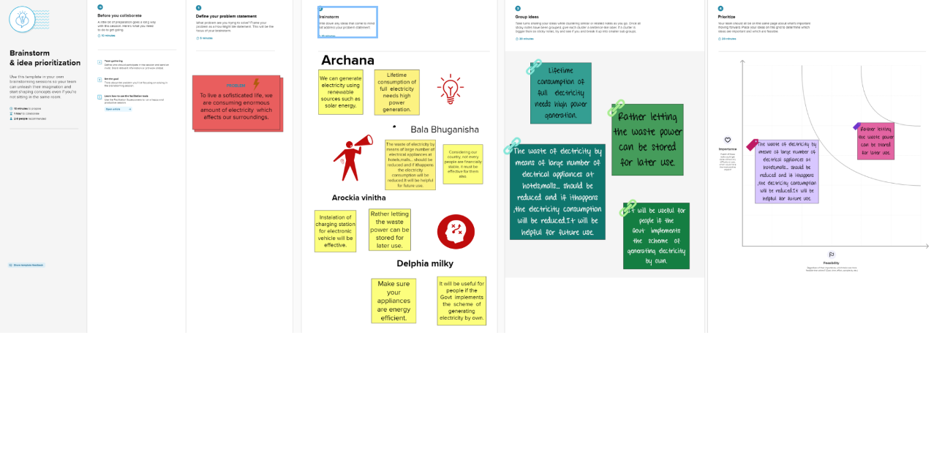

RESULT:

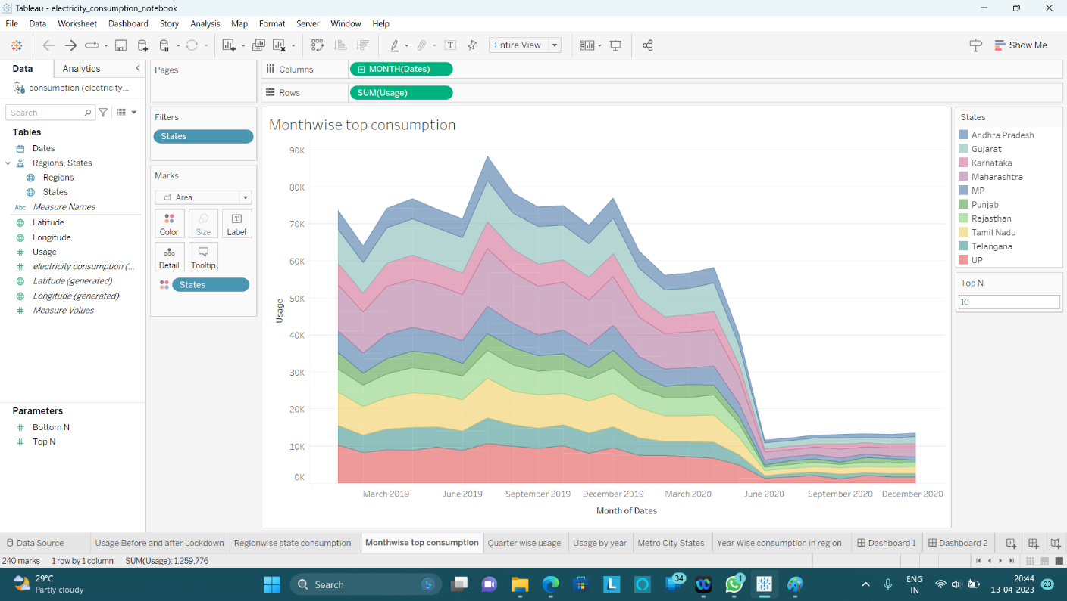

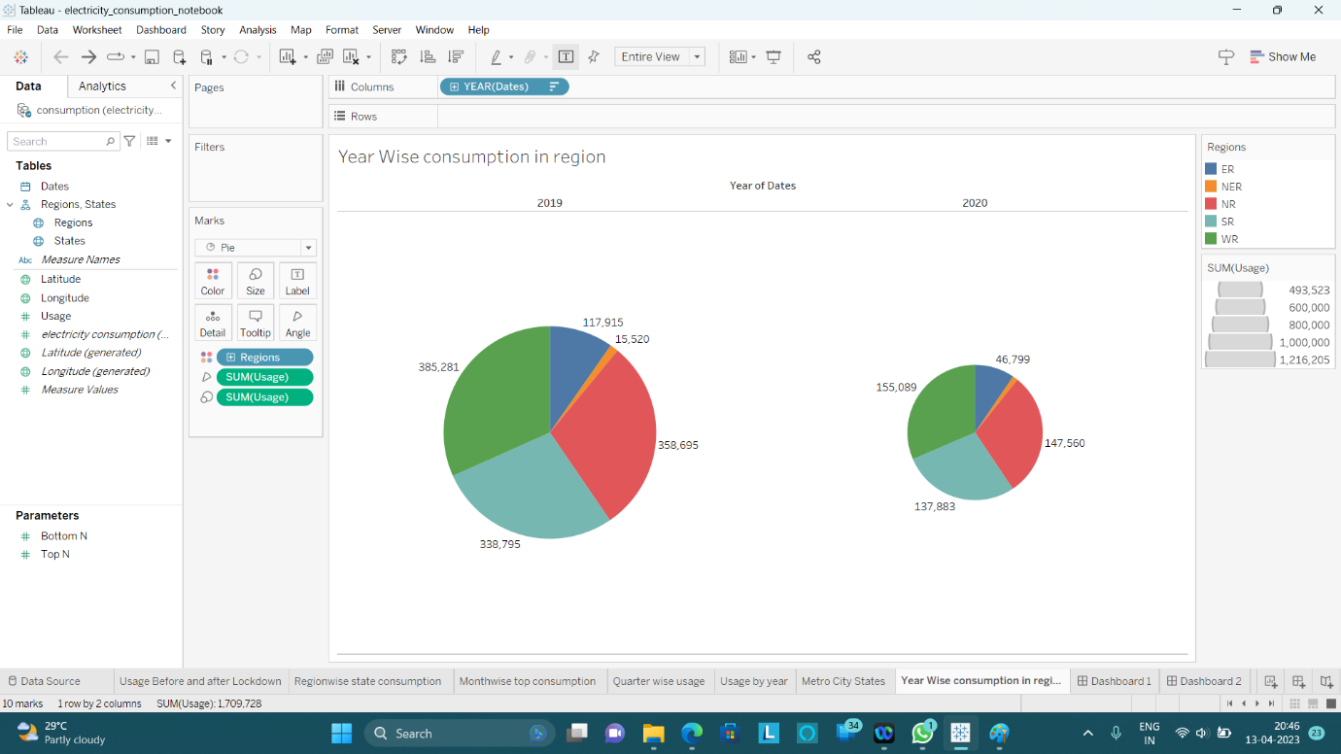

ADVANTAGES & DISADVANTAGES**:**

* Lower energy bills
* Improved indoor air quality
* Cleaner environment
* Power plants that burn biomass release sulfur dioxide and nitrogen oxides, two undesirable pollutants, into the air.
* Power plants that burn fossil fuel pump carbon dioxide into the atmosphere.

APPLICATIONS:

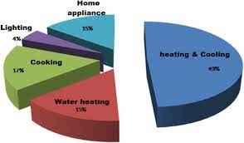Carbon dioxide is a greenhouse gas that causes Earth's temperature to rise.

Conclusion:

Electricity Consumption Stats.

* Maharashtra is the Highest Electricity consumption user of India.
* Gujarat is the Second Highest Electricity consumption user of India.
* Sikkim is the Lowest Electricity Consumption user of India .

Electricity Consumption before and during Lockdown in India

Electricity consumption was more in 2019 in month of March-June before Lockdown

Electricity Consumption was less in 2020 in month of March-June during the Lockdown

Electricity Consumption in Quarters

* Electricity Consumption in 2019 for Quarter 3 was Highest.
* Electricity Consumption in 2019 for Quarter 1 was Lowest.
* Electricity Consumption in 2020 for Quarter 3 was Lowest.
* Electricity Consumption in 2020 for Quarter 1 was Highest.

Electricity Consumption in Regions

* Total Electricity consumption in Western Region is Highest.
* Total Electricity consumption in North Eastern Region is Lowest.
* Electricity Consumption in 2020 for Quarter 3 was Lowest.
* Electricity Consumption in 2020 for Quarter 1 was Highest**.**

FUTURE SCOPE:

In the Stated Policies Scenario, global electricity demand grows at 2.1% per year to 2040, twice the rate of primary energy demand. This raises electricity's share in total final energy consumption from 19% in 2018 to 24% in 2040. Electricity demand growth is set to be particularly strong in developing economies. As the Indian government plans to increase electrification of rail-route kilometers from 40 percent presently to 77 percent by 2022, the level of electricity consumption achieved by 2030 could be 35-43 TWh, growing at 5.0-6.3 percent CAGR from 17 TWh in 2015.